week8
Iyenoma Goodnews Osabuohien
2026-03-17
contentdatas <- read.csv("../data/contentdatas.csv")
library(dplyr)
##
## Attaching package: 'dplyr'
## The following objects are masked from 'package:stats':
##
## filter, lag
## The following objects are masked from 'package:base':
##
## intersect, setdiff, setequal, union
library(corrplot)
## corrplot 0.95 loaded
plot(contentdatas)
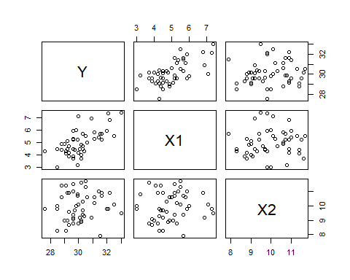
summary(contentdatas)
## Y X1 X2
## Min. :27.60 Min. :3.000 Min. : 7.900
## 1st Qu.:29.30 1st Qu.:4.300 1st Qu.: 9.200
## Median :29.95 Median :4.900 Median : 9.800
## Mean :30.11 Mean :4.974 Mean : 9.944
## 3rd Qu.:30.57 3rd Qu.:5.500 3rd Qu.:10.775
## Max. :33.00 Max. :7.400 Max. :11.700
#check_model(model_r)
# very useless
df1 <- contentdatas
cor(df1)
## Y X1 X2
## Y 1.0000000 0.66053224 0.11125923
## X1 0.6605322 1.00000000 0.08279095
## X2 0.1112592 0.08279095 1.00000000
corrplot(cor(df1), method="number")
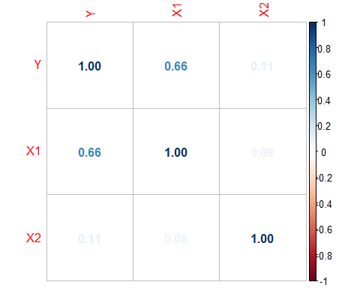
corrplot(cor(df1), method="color")
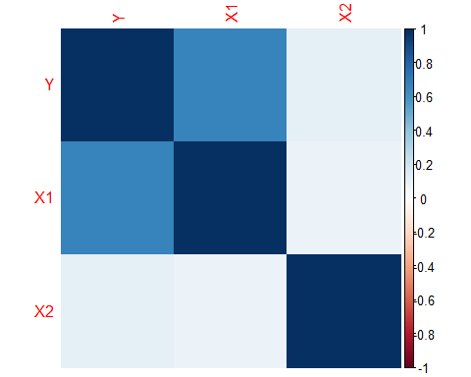
corrplot(cor(df1), method="circle")
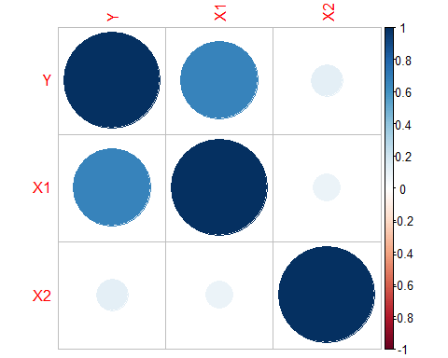
corrplot(cor(df1), method="square")
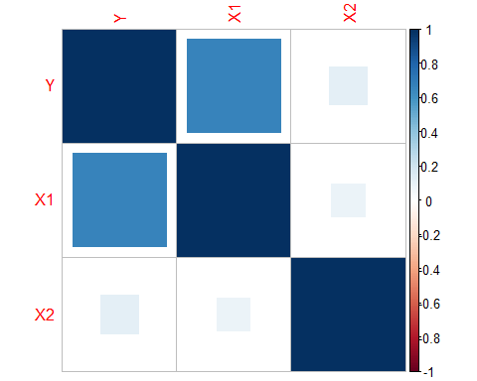

Multiple regression
model_r2 <- lm(Y ~ X1 + X2, data = contentdatas)
summary(model_r2)
##
## Call:
## lm(formula = Y ~ X1 + X2, data = contentdatas)
##
## Residuals:
## Min 1Q Median 3Q Max
## -2.00654 -0.61509 -0.02576 0.66596 2.00130
##
## Coefficients:
## Estimate Std. Error t value Pr(>|t|)
## (Intercept) 25.82582 1.37492 18.784 < 2e-16 ***
## X1 0.72674 0.12143 5.985 2.84e-07 ***
## X2 0.06691 0.12872 0.520 0.606
## ---
## Signif. codes: 0 '***' 0.001 '**' 0.01 '*' 0.05 '.' 0.1 ' ' 1
##
## Residual standard error: 0.8733 on 47 degrees of freedom
## Multiple R-squared: 0.4395, Adjusted R-squared: 0.4157
## F-statistic: 18.43 on 2 and 47 DF, p-value: 1.233e-06
summary(model_r2)$coefficients
## Estimate Std. Error t value Pr(>|t|)
## (Intercept) 25.82582030 1.3749167 18.7835522 1.737803e-23
## X1 0.72673595 0.1214275 5.9849369 2.836678e-07
## X2 0.06691423 0.1287193 0.5198461 6.056108e-01
round(coef(model_r2), 3)
## (Intercept) X1 X2
## 25.826 0.727 0.067
summary(model_r2)$coefficients[, "Pr(>|t|)"]
## (Intercept) X1 X2
## 1.737803e-23 2.836678e-07 6.056108e-01
round(summary(model_r2)$coefficients[, "Pr(>|t|)"], 3)
## (Intercept) X1 X2
## 0.000 0.000 0.606
summary(model_r2)
##
## Call:
## lm(formula = Y ~ X1 + X2, data = contentdatas)
##
## Residuals:
## Min 1Q Median 3Q Max
## -2.00654 -0.61509 -0.02576 0.66596 2.00130
##
## Coefficients:
## Estimate Std. Error t value Pr(>|t|)
## (Intercept) 25.82582 1.37492 18.784 < 2e-16 ***
## X1 0.72674 0.12143 5.985 2.84e-07 ***
## X2 0.06691 0.12872 0.520 0.606
## ---
## Signif. codes: 0 '***' 0.001 '**' 0.01 '*' 0.05 '.' 0.1 ' ' 1
##
## Residual standard error: 0.8733 on 47 degrees of freedom
## Multiple R-squared: 0.4395, Adjusted R-squared: 0.4157
## F-statistic: 18.43 on 2 and 47 DF, p-value: 1.233e-06

R Markdown
This is an R Markdown document. Markdown is a simple formatting syntax for authoring HTML, PDF, and MS Word documents. For more details on using R Markdown see http://rmarkdown.rstudio.com.
When you click the Knit button a document will be generated that includes both content as well as the output of any embedded R code chunks within the document. You can embed an R code chunk like this:

Including Plots
You can also embed plots, for example:
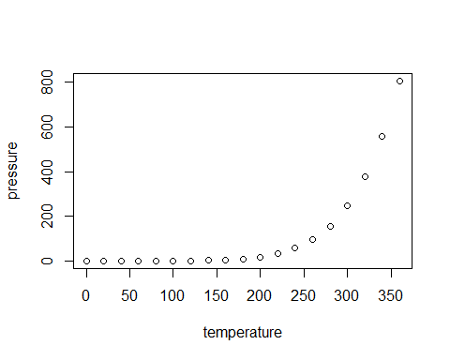
Note that the echo = FALSE parameter was added to the code chunk to prevent printing of the R code that generated the plot.

